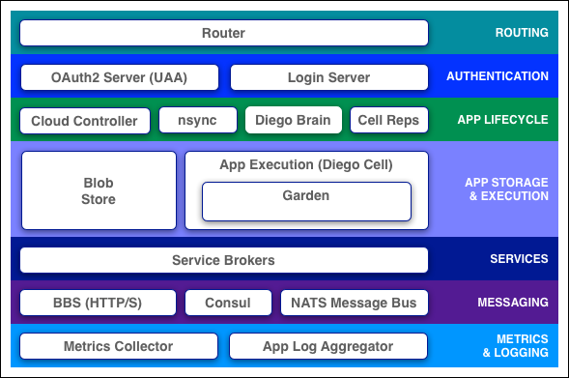

http://docs.cloudfoundry.org/concepts/architecture/